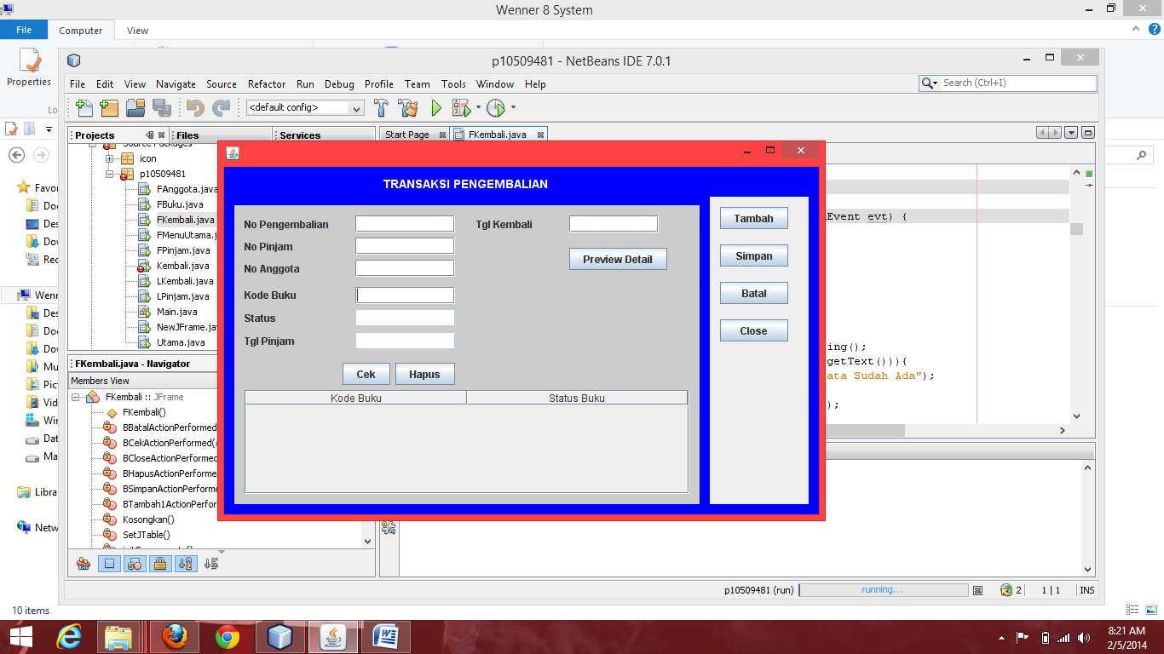

txtTglKembali

txtTglPinjam

txtStatus

txtNoBuku

txtNoAnggota

txtNoKembali

txtNoPinjam

Variabel

Button Cek🡪 Bcek

Button Hapus 🡪 Bhapus

Button Tambah 🡪 Btambah

Button Simpan 🡪 Bsimpan

Button Batal 🡪 BBatal

Button Close 🡪 BClose

1. **Event Pada BCek**

**private void BCekActionPerformed(java.awt.event.ActionEvent evt) {**

// TODO add your handling code here:

String KodeBuku;

boolean ketemu=false;

int jum=tabMode.getRowCount();

if(txtStatus.getText().equalsIgnoreCase("Pinjam")){

for(int i=0;i<jum;i++){

KodeBuku = tabMode.getValueAt(i, 0).toString();

if(KodeBuku.equalsIgnoreCase(txtKodeBuku.getText())){

JOptionPane.showMessageDialog(this,"Data Sudah Ada");

ketemu=true;

TKembali.setRowSelectionInterval(i, i);

break;}

}

if (ketemu==false)

{ String Data[]={txtKodeBuku.getText(),txtStatus.getText()};

tabMode.addRow(Data);

}

}

else

JOptionPane.showMessageDialog(this, "Buku ini belum dipinjam","Informasi",JOptionPane.INFORMATION_MESSAGE);

}

1. **Event BHAPUS**

**private void BHapusActionPerformed(java.awt.event.ActionEvent evt) {**

// TODO add your handling code here:

int row=TKembali.getSelectedRowCount();

if(row>0)

tabMode.removeRow(row-1);

else

JOptionPane.showMessageDialog(this, "Hapus Gagal, Pilih Data yang akan dihapus");

}

1. Event Simpan

private void BSimpanActionPerformed(java.awt.event.ActionEvent evt) {

// TODO add your handling code here:

try{

Class.forName("sun.jdbc.odbc.JdbcOdbcDriver");

conn=DriverManager.getConnection("jdbc:odbc:perpus_10509481");

String sql="insert into Kembali values(?,?,?,?,?)";

PreparedStatement st=conn.prepareStatement(sql);

st.setString(1,txtNoKembali.getText());

st.setString(2,txtNoPinjam.getText());

st.setString(3,txtNoAnggota.getText());

st.setString(4,txtTglPinjam.getText());

st.setString(5,txtTglKembali.getText());

int rs= st.executeUpdate();

String KodeBuku;

int jum=tabMode.getRowCount();

for(int i=0;i<jum;i++){

KodeBuku = tabMode.getValueAt(i, 0).toString();

String sql3="update Buku set Status=? where KodeBuku=?";

PreparedStatement st3=conn.prepareStatement(sql3);

st3.setString(1,"Ada");

st3.setString(2,KodeBuku);

st3.executeUpdate();

String sql2="insert into DetailKembali values(?,?,?)";

PreparedStatement st2=conn.prepareStatement(sql2);

st2.setString(1,txtNoKembali.getText());

st2.setString(2,txtKodeBuku.getText());

st2.setString(3,"Dipinjam");

st2.executeUpdate();

}

if((rs>0)){

JOptionPane.showMessageDialog(this,"Input Berhasil");

Kosongkan();

}

else

JOptionPane.showMessageDialog(this,"Input Gagal");

conn.close();

}

catch(Exception e){

System.out.println("Exception " +e );

}

}

1. **txtKeyPressed Untuk NoPinjam**

private void txtNoPinjamKeyPressed(java.awt.event.KeyEvent evt) {

// TODO add your handling code here:

if (evt.getKeyCode()==10){

try {

Class.forName("sun.jdbc.odbc.JdbcOdbcDriver");

conn=DriverManager.getConnection("jdbc:odbc:perpus_10509481");

String sql="select * from Pinjam Where NoPinjam=?";

PreparedStatement st=conn.prepareStatement(sql);

st.setString(1,txtNoPinjam.getText());

ResultSet rs= st.executeQuery();

String sql2="select * from DetailPinjam Where NoPinjam=?";

PreparedStatement st2=conn.prepareStatement(sql2);

st2.setString(1,txtNoPinjam.getText());

ResultSet rs2= st2.executeQuery();

if( (rs.next())&&(rs2.next())){

String TglPinjam = rs.getString("TglPinjam");

String NoAnggota = rs.getString("NoAnggota");

String KodeBuku = rs2.getString("KodeBuku");

String Status = rs2.getString("Status");

txtTglPinjam.setText(TglPinjam);

txtNoAnggota.setText(NoAnggota);

txtKodeBuku.setText(KodeBuku);

txtStatus.setText(Status);

}else

{

JOptionPane.showMessageDialog(this, "Kode Pinjam Tidak Ada","Informasi",JOptionPane.INFORMATION_MESSAGE);

txtTglPinjam.setText("");

txtNoAnggota.setText("");

txtKodeBuku.setText("");

txtStatus.setText("");

}

} // akhir try

catch(Exception e){

System.out.println("Exception : " +e);

}

}

}

1. **Method setJTable();**

private void SetJTable(){

String [] JudulKolom={"Kode Buku","Status Buku"};

tabMode = new DefaultTableModel(null, JudulKolom){

boolean[] canEdit = new boolean [] { false, false };

@Override

public boolean isCellEditable(int rowIndex, int columnIndex) {

return canEdit [columnIndex];

}

};

TKembali.setModel(tabMode);

}

1. **Method Kosongkan();**

private void Kosongkan(){

txtNoPinjam.setText("");

txtNoAnggota.setText("");

txtTglPinjam.setText("");

txtKodeBuku.setText("");

txtStatus.setText("");

int row=tabMode.getRowCount();

for(int i=0;i<row;i++){

tabMode.removeRow(0);

}

txtNoPinjam.setEnabled(false);

txtNoAnggota.setEnabled(false);

txtKodeBuku.setEnabled(false);

}

